

  EOCR-PMZ
  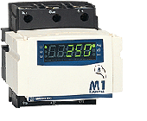
  EOCR-PFZ
  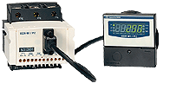
  ■ | MCU( Microprocessor Control Unit )Based
  ■ | Convenient installation  -PMZ:Panel Mounting Type  -PFZ:Panel Flush Mounting Type
  ■ | Full mode function:easy to set
  ■ | Three Integral Current Transformers
  ■ | Full cover protection Function
  ■ | Wide Current Range protection from 0.1A to 3600A by just 1 model
  ■ | Built-in digital ammeter
  ■ | Total running time display
  ■ | Current display like L1 -> L2 -> L3 -> GF...
  ■ | Bar-Graph monitoring on impending overload trip
  ■ | Selectable time-current characteristics[Inverse/Inverse based on thermal Memory (Thermal Inverse) /Definite]
  ■ | 4~20mA current loop communcations
  ■ | Test Function
  ■ | Operates in wide ambient temperature range
  ■ | Selectable Fail-safe Operation/ No volt Release(FS:ON)

Protective Item | Trip Time
Over-current | DEF:0.2~30 sec, INV:1~30 class
Under-current | 0.5~30 sec
Phase Reversal | 0.1~0.3 sec
Phase Unbalance | within 8 sec
Ground Fault | DEF:0.1~10 sec, INV:1~10 class
Locked Rotor | 0.5 sec after d-time
stall | 0.05~10 sec

Current Setting Range | Over-Current(oc) |  | 0.1~3600A(Over 60A with External CTs)
Current Setting Range | Under-Current(uc) |  | OFF/0.5~less than "OC" setting
Current Setting Range | Ground Fault Current(Ec) |  | OFF
Current Setting Range |  |  | 0.3~10A:definite
Current Setting Range |  |  | 0.3~1A definite/inverse (selectable)
Time Setting | Starting Delay Time(dt) |  | OFF~200sec
Time Setting | Over-Current Trip Time(ot) |  | Definite Time | 0.2~30sec
Time Setting |  |  | Inverse Time | 1~30class(30curves)
Time Setting | Under-Current Trip Time(ut) |  | 0.5~30sec, definite time characteristics, if "uc" mode selects OFF, then ut is automatically disabled.
Time Setting | Ground Fault Trip Time(Et) |  | Definite/Inverse : 0.05, 0.1~1~10 sec
Time Setting | Ground Failt Starting Time(Edt) |  | OFF/1~10 sec
Tolerance | Current |  | ±5%
Tolerance | Time |  | ±5%
Conrol Power | 220 |  | 85~250VAC/DC, 50/60Hz
Output Relay | OL(SH) |  | 2-SPST | 3A/250VAC, Resistive
Output Relay | GR |  | 1-SPST | 3A/250VAC, Resistive
Environment | Temperature | Store | -30 ~80 ℃
Environment | Temperature | Operation | -20 ~60 ℃
Environment | Humidity |  | 30~85% RH, Non-Condensing
Display | 7-Segment LEDs |  | 3phase current,Trip cause, Operating hour
Display | Bar-Graph |  | Load factor for current setting(50~100%)
Insulation |  |  | Between casing and circuit:over 10MΩ, 500VDC
Dielectric Strength | Between casing and circuit |  | Between casing and circuit 2000VAC,60Hz, 1min
Dielectric Strength | Between open contacts |  | Between open contacts 1000VAC, 60Hz, 1min
Dielectric Strength | Between circuit |  | Between circuit 2000VAC,60Hz, 1min
Electrostatic Discharge |  | IEC61000-4-2 | Lever3:Air Discharge:±8kV, Contact Discharge:±6kV
Radiated Electromagnetic Field Disturbance |  | IEC61000-4-3 | Lever3:10V/m,150MHz&450MHz Portable transceiver
EFT/Burst |  | IEC61000-4-4 | Lever3:±2kV, 1min
Surge |  | IEC61000-4-5 | Lever3:1 x 50 ,±4kV(0˚,90˚,180˚,270˚)
1MHz Burst disturbance |  | IEC61000-4-12 | Lever3:±2.5kV,1MHz
Conducted Emission |  | EN55011 | Class B

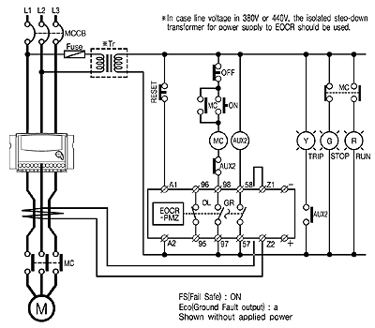
EOCR-PMZ
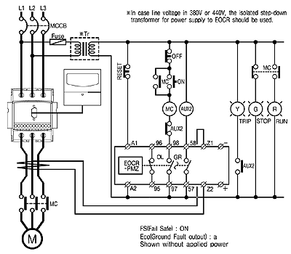
EOCR-PFZ



