

  EOCR-3DE
  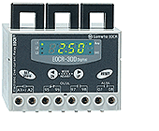
  EOCR-FDE
  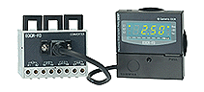
  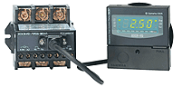
  ■ | Compact Design
  ■ | MCU( Microprocessor Control Unit ) Based
  ■ | Three Integral Current Transformers
  ■ | Multiple Protection Functions
  ■ | Digital Ammeter/3 Phase Current Display
  ■ | Troubleshooting/Trip Cause Memory, Display
  ■ | Adjustable Operating Features by Mode switch
  ■ | Wide Current Adjustment Range
  ■ | Selectable Time-Current Characteristics(Inverse/Definite)
  ■ | Manual(Instantaneous)/Electrical(Remote)Reset
  ■ | Test Function
  ■ | Ambient Insensitive
  ■ | Selectable Fail-safe and Non-fail-safe Operation Modes
  ■ | Inverter (20~400Hz)
  ■ | EOCR-3DE : Panel Mounting type
  ■ | EOCR-FDE : Flush Mounting type(Display)

Protective Item | Trip Time
Over-current | DEF : 0.2~30sec INV : 1~30
Undercurrent | 0.5~30 sec
Phase Loss | within 3 sec
Phase Unbalance | within 8 sec
Phase Reversal | 0.1~0.3 sec
Locked Rotor | Lock : within 0.5sec after D-time(in DEF set)  Stall : 0.05 ~ 10sec (in DEF set)

Current Range | Over Current |  | 0.5~960A(Over 60A with External CTs)
Current Range | Under Current |  | 0.5~59A/OFF(Over 60A with External CTs)
Current Range | Phase Unbalance |  | 5~50%
Alert Setting |  |  | 50~100% of Oc setting
Time Setting Range | Start Delay Time (D-TIME) |  | 1~200sec (Definitive)
Time Setting Range | Trip Delay Time Setting (O-TIME) | INV | 1-30
Time Setting Range | Trip Delay Time Setting (O-TIME) | DEF | 0.2-30 sec
Control Voltage |  |  | 110VAC±15%, 220VAC±15%, 24VAC/DC
Output Relay |  | OC/UC | 2-SPST, 3A/250VAC Resistive
 |  | AL/UC | 1-SPST,3A/250VAC Resistive
Time Characteristic |  | In/"tc"mode | Inverse
 |  | dE/"tc"mode | Definite
Trobleshooting/Trip Indication |  |  | LED Display(3 Trip causes memory)
Current Sensing |  |  | 3-CT
Mounting |  |  | 35mm DIN-Rail/Panel

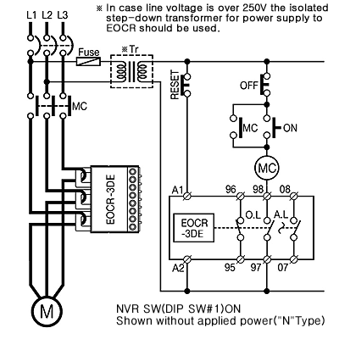
EOCR-3DE
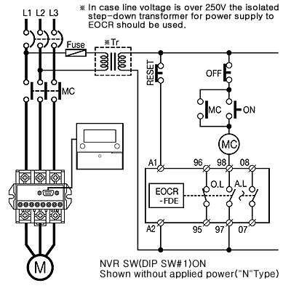
EOCR-FDE



